Functional Characteristics of a Processor

Exercise

- Explain the factors that affect the speed at which a computer program will be executed.
The factors are the amount of RAM and the speed of the processor. E.g. 64 bit
- Computer systems built using the von Neuman architecture use the stored program concept. Explain this concept.
The program is held in the RAM and the code is fetched by the data bus. The code is decoded and executed by the processor line by line.
- Using the Draw facilities in Microsoft Word, create a diagram showing all the components involved in program execution. Each element should be identified with its name and a short description of the task it performs. The diagram should include the CPU components, RAM and the buses.
RAM
(Holds Programs)
Control Unit
General Registers

Address Bus
ALU – Arithmetic Logic Unit

Clock
CIR – Currenct Instruction Register
Data Bus

Program Computer

- Describe how the fetch-execute cycle performs the execution of a computer program.

- The address in the PC (Program Counter) is placed in the MAR(Memory Address Register)
- The address travels to the RAM(Random Access Memory) on the address bus
- The program instruction is placed on the data bus
- The instruction is placed in the MBR(Memory Buffer Register)
- The instruction is placed in the CIR (Current Instruction Register) where it is decoded and executed
- The PC(Program Counter) is increased to the point at the next instruction in the RAM(Random Access Memory)
- Examination Question from CPT1 – June 2007. The diagram shows an incomplete diagram of typical computer system architecture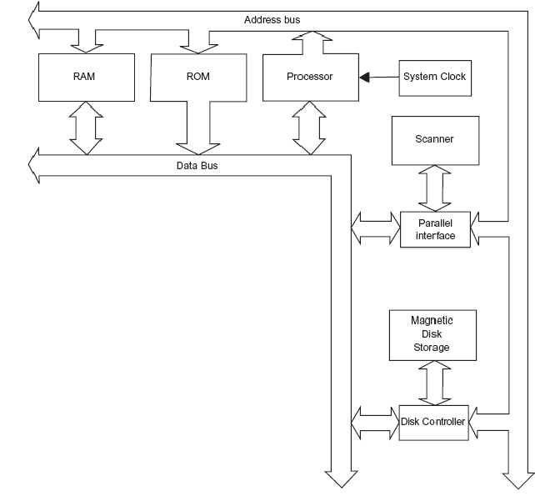
  - Two of the components shown in the diagram for a typical PC, are the RAM and the Magnetic Disk Storage.
Select from the list below a typical specification value for each component.
300 GB 2 MHz 1 GB 128 kbps 3.0 MHz
    - RAM – 1GB
    - Magnetic Disk Storage – 300GB
  - What is the name of the third bus has been omitted from the diagram.
Control Bus
  - Explain why the data bus is bi-directional, but the address bus is one-way only.
Variables and Information have to be taken to the RAM and stored data and program code has to be taken from the RAM to the processor; therefore the data bus has to be bi-directional.
The address bus is only one way because it only has to go to the RAM for fetching the instructions/code.
  - The processor performs different types of operations; for example, arithmetic operations. Name one other type of operation performed in the CPU.
A Program counter keeps track of the line of instructions/code that has been taken/yet to be taken.
  - Explain the stored program concept.
- This is the concept of a machine which executes instructions.
- The instructions are held in memory and then fetched individually by a processor, which first decodes the instruction and then executes it.

- Some of the internal components of a computer system are processor, main memory, control bus, address bus, data bus, keyboard controller, VDU controller, disk controller.
The diagram below shows how these are connected.
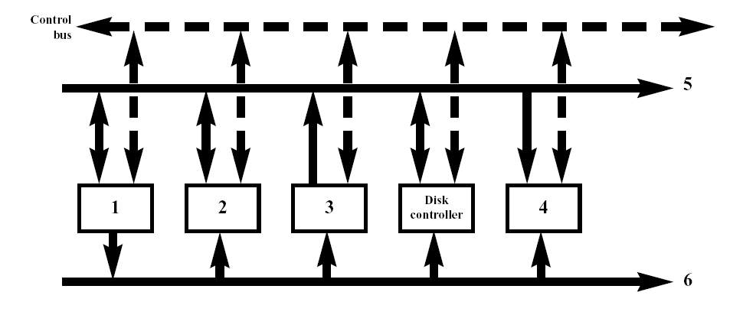
- Give the correct name for each of the following components labelled in the diagram above as 1 to 6.
- Processor
- RAM
- Keyboard controller
- VDU controller
5 – Data Bus
6 – Address Bus
- Computer systems built using the von Neumann architecture use the stored program concept.
  - Where is a program stored while it is being executed?
RAM
  - Where is the data stored?
RAM
- Some of the components of a computer system are
Internal components
Clock 1
Data Bus 2
Address Bus 3
Main Memory 4
VDU Controller 5
Keyboard Controller 6
Disk Controller 7
Peripherals
Keyboard 8
Monitor 9
Secondary Storage 10
Figure 1 is partially filled in. Complete Figure 1 by writing a number from the list above in each empty circle.
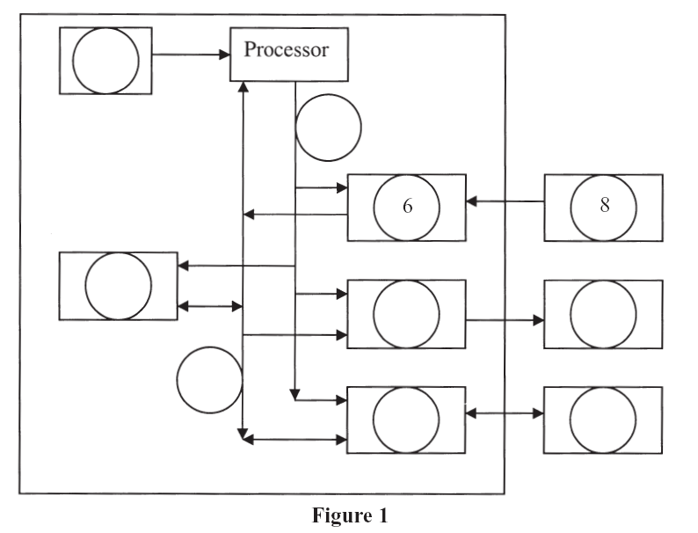
1
4
9
10
7
3
2
5

